Assignment 1

9th June

#TASK 1
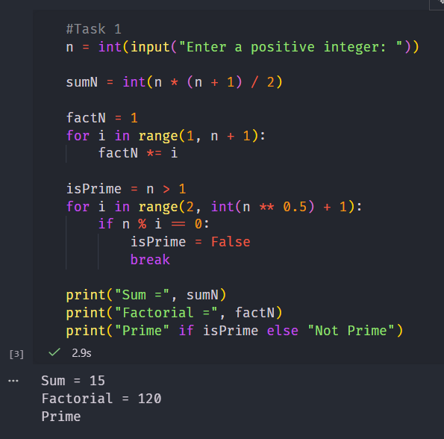

#TASK 2
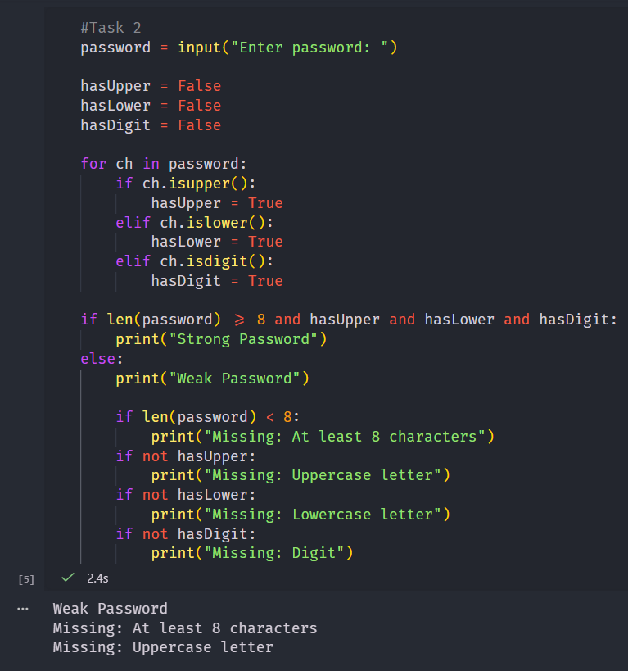

# TASK 3
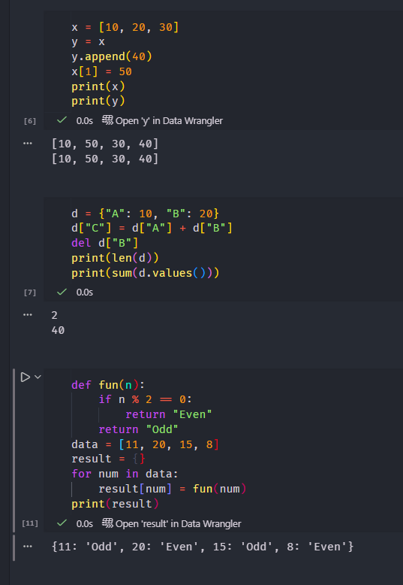

Submitted by - Tanishq Singh Anand

